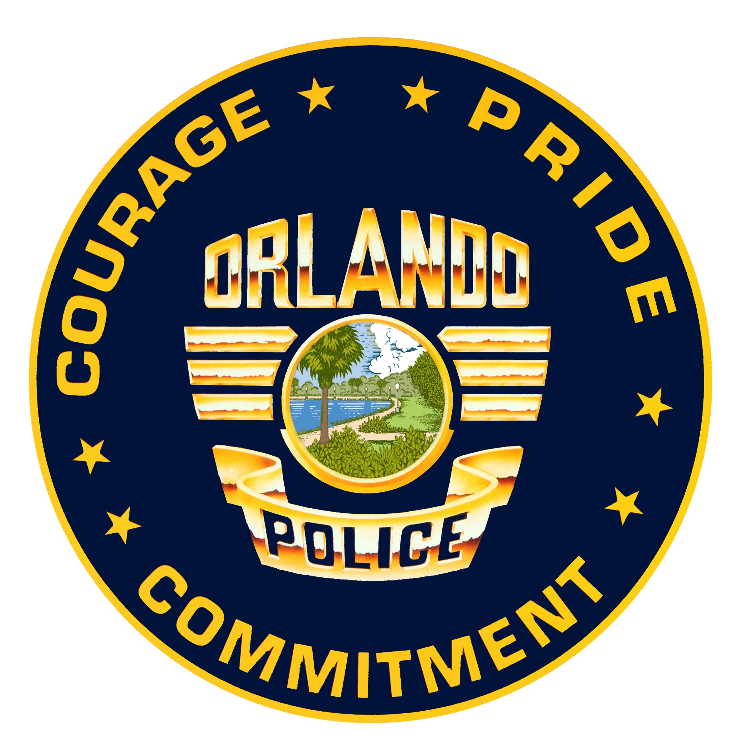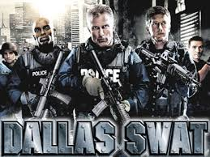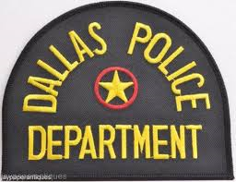
THE SOUTHEAST MISSOURI SWAT CHALLENGE PRESENTS
THE ORLANDO POLICE DEPARTMENT SWAT AND DALLAS SWAT
AT THE 5TH ANNUAL EVENT
On June 12, 2016, a 29-year-old male, killed 49 people and wounded 53 others in a terrorist attack inside Pulse, a nightclub in Orlando, Florida. The suspect was shot and killed by Orlando Police Department SWAT officers after a three-hour standoff. It was also the deadliest attack on the United States since the 9/11 attacks. In a 911 call shortly after the shooting began, the suspect swore allegience to the leader of the Islamic State of Iraq and the Levantt (ISIL), Abu-Bakr al-baghdadi. The suspect was engaged by OPD patrol units and surrounding agencies in a gun battle that turned into a hostage incident.
On July 7, 2016, Dallas PD filled the streets of downtown Dallas to work a BLM protest and march. At 8:45 pm a lone gunmen began an ambush firing on law enforocement from the roof tops above them. During the next hour the suspect shot 12 law enforcement officers killing 5 of them making it the deadlisest attack on law enforcment since 9/11. Dallas patrol officers and SWAT cornored the suspect in a parking gargae and a shootout and stand off occurred. Dallas SWAT initiated a robot armed with C4 explosives to take out the suspect and it had the success of doing so.
The SEMO SWAT Challenge is honored to have members of the Orlando PD SWAT and Dallas PD SWAT at our event to provide their debriefs and stories of these incidents. Det. Raul Rivas and Officer Timothy Stanley from Orlando SWAT, and Deputy Chief Bill Humphrey’s Dallas SWAT Commander will be the presenters and speaker during the event. Friday morning from 8:00am till 12:00pm the Club Pulse debrief will be given and is open to ALL Police, Fire, and EMS to attend you will need a department ID to get into the debrief. If your not a comepting team member or partaking in training classes we ask that you RSVP for the debrief as we will be able to accomaodate up to 1200 and we plan on having a full house. Friday night at 7:00pm is our event kick-off dinner and we will have D.C Bill Humphrey’s as our guest speaker during the dinner. If interested in partaking in either event please RSVP and contact Sgt. Jason Fitzwater at (314) 920-3930 or fitzwater0912@gmail.com. www.semoswatchallenge.com
